Secure Settings
Categorize Options Procedure

Revision
Version 1
9/4/25 7:40 AM

SME
Charles Wilson

Abstract
This document describes the procedure used to perform the security option categorization activity described in the AVCDL ^{[1]} secondary document Secure Settings Document ^{[2]}.

Group / Owner
Security / Security Architect

Motivation
This document is motivated by the need to ensure that the software is built with tools whose selected settings are based on cybersecurity best practices. This is necessary given the nature of safety-critical, cyber-physical systems
Note: Within the context of this document, the terms security and cybersecurity are used interchangeably. It is presumed that the term security is being used in reference to cybersecurity and not physical security.

License
This work was created by Torc Robotics and is licensed under the Creative Commons Attribution-Share Alike (CC BY-SA-4.0) License.
https://creativecommons.org/licenses/by/4.0/legalcode

Audience
The audience of this document is the cybersecurity practitioner who will be conducting cybersecurity-specific tool setting options categorization.

Completeness of Output
Since the categorization of security options is an as-is analysis, it is critical to ensure that the information gathered is as accurate and complete as possible. As with any cybersecurity activity, it is not the place of the cybersecurity SME to make unsupported assertions. All information should be based on the best available sources and confirmed where possible prior to inclusion.
Note: When information is not available for either a given section of the template or parts thereof, this should be noted.

Disposition of Output
Once completed, the generated output should be managed in the organization’s document management system (DMS) as a document of record.

Entry Criteria
This document assumes that the reader understands the purpose of cybersecurity-relevant tool settings. Further, that the reader has read and understood the AVCDL Secure Settings Document secondary document.

Prerequisites – Security SME

Qualifications
It is required that the cybersecurity SME is both a qualified and trained security architect (shown above on title page as Owner) as defined by the NIST NCWF role SP-ARC-002 and detailed in section 12.7 Security Architect of the AVCDL primary document.

Knowledge
It is required that the cybersecurity SME understands the purpose of cybersecurity-relevant tool settings.

Background Information
It is required that the cybersecurity SME has read and understands the AVCDL Secure Settings Document ^{[2]} secondary document. Additionally, that the cybersecurity SME has taken training relevant to this activity.

Prerequisites – Input Materials
It is required that the cybersecurity SME acquire all relevant documentation necessary to complete the procedure.

Categorize Security Options Activity
The workflow diagram for the categorize security options activity of the Secure Settings Document is shown below.
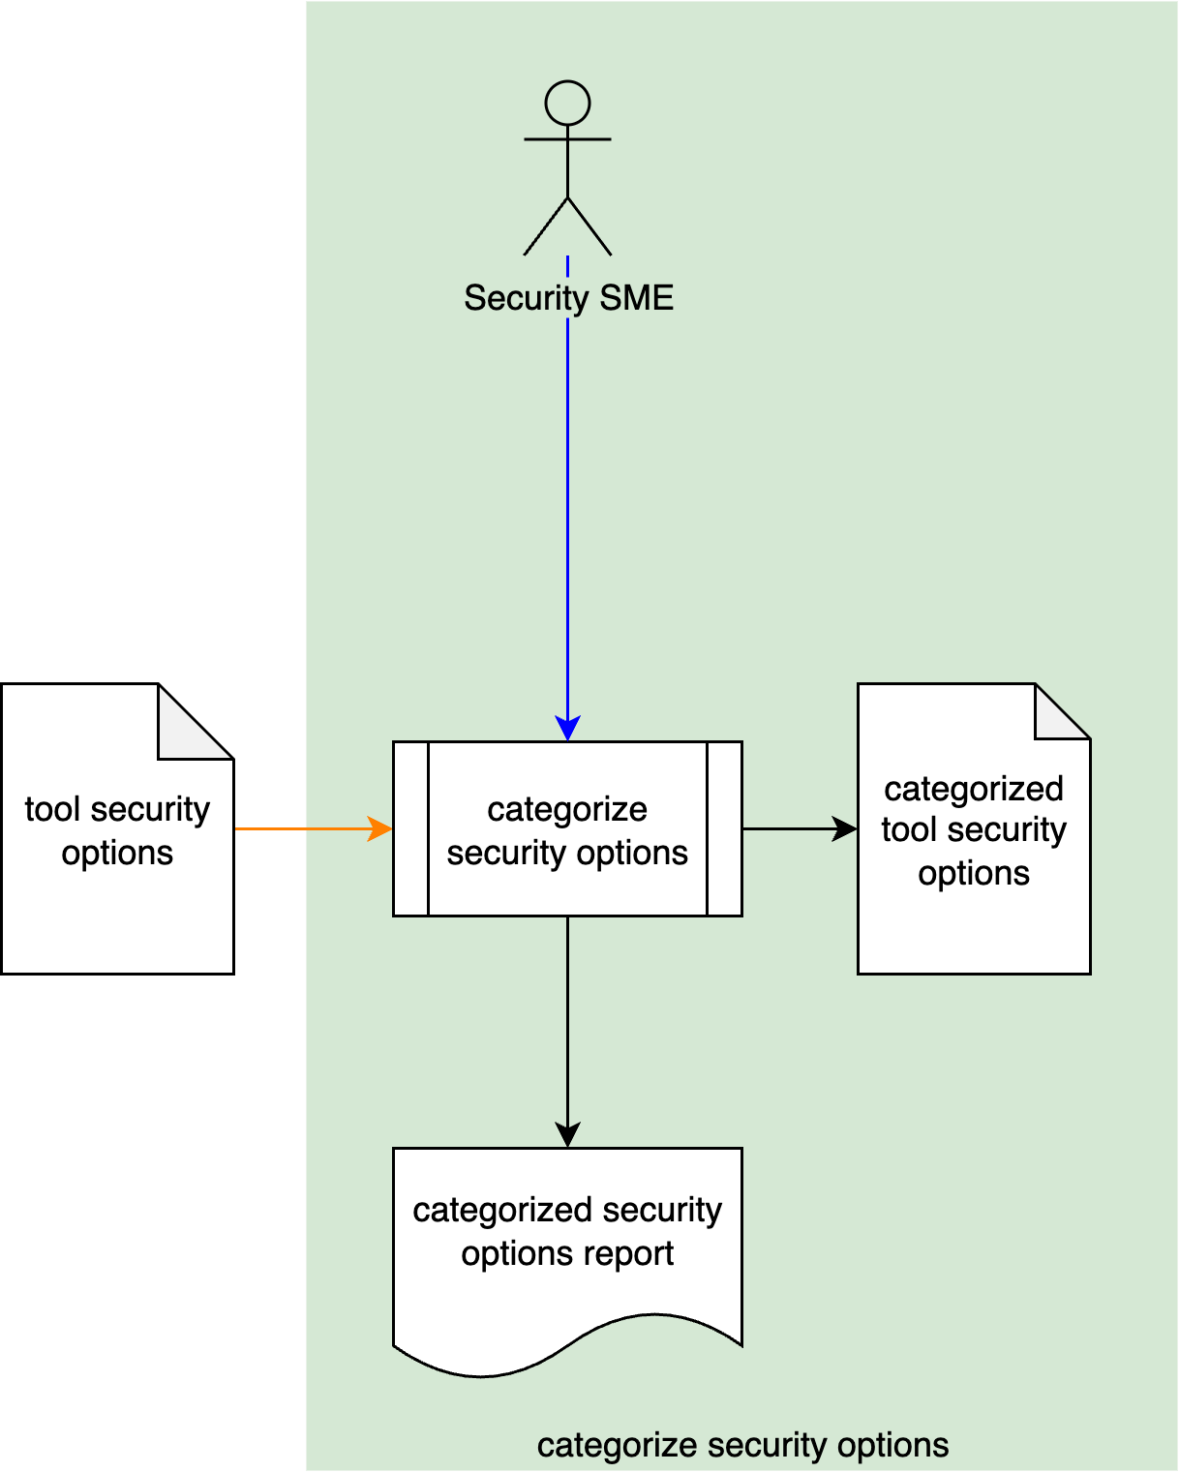
The Security SME reviews the Tool Security Options created in the Secure Settings – Identify Security Options ^{[4]} activity and assigns each a security priority category. A Categorized Tool Security Options list is generated. A Categorized Security Options Report is generated.
Note: It is recommended that the Categorized Security Options Report be organized in priority order.
Note: It is important to keep in mind that categorization is done solely from a cybersecurity perspective. This is because not all elements will adopt use of the options based only on category. The categorized options will be further refined during the Select Security Options activity.

Security Priority Category
The purpose of assigning a security priority category to each of the options is to allow the development teams the ability to select the options that best fit the organization’s priorities. In a perfect world, one could assert that all of the identified cybersecurity-relevant options should be employed in order to achieve the highest level of cybersecurity rigor. This is impractical for all but the most mature (from the product cybersecurity perspective) organizations. As such, it is important to assign a priority to each of the options to facilitate their selection.

Multi-value
When the organization has a pre-existing track record of applying cybersecurity-relevant settings to a particular tool, it may be appropriate to use a multi-value approach, an example of which is shown below.
Here we have low, medium, and high values.
It is important when using multi-value categorization, that there be a clear methodology for when options from each category are applied. There is no practical use for highly granular categories if only the most critical one is ever addressed. Keep this in mind when establishing the value set.

Two-value
When the organization is applying cybersecurity-relevant settings to a particular tool for the first time, the best approach is to use a simple two-value categorization as show below.
Here we have only may do and must do values.
In most situations, this categorization will be sufficient. As the organization becomes increasingly mature with respect to the implementation of the must do options, the category criteria may be adjusted and options from the may do subset can be reclassified.
Note: Regardless of the category value set, the determinants for each value should documented in such a way that enables any competent cybersecurity SME to apply them consistently.

Methodology
The methodology for this activity is as follows:
- Define a set of categories.
- Document the intent of each.
- Document the qualifications of each.
- Assign a category to each identified option.

Tool Security Options Template
The tool’s cybersecurity-relevant option category information may be documented using the AVCDL tool cybersecurity options template Microsoft Excel workbook ^{[3]}.
Note: Other forms of documentation are permissible so long as they provide the information laid out in this document.
Note: It is presumed that the workbook used was created as a result of undertaking the Identify Security Options activity and that only the categories sheet and category fields in the options sheet will need to be entered.
There are six sheets in the workbook. They are:
- Cover sheet
- Revision history
- Reference documents
- Options
- Categories
- Legend
These will be addressed in turn.
Note: This material will include sections previously covered in the Identify Security Options activity.

Duplication of Rows in the Various Sheets
When there is the need to add rows to the various sheets of the workbook, be sure to duplicate an existing row. This is because validation checks are attached to some of the cells which also enables the use of dropdown lists.

Cover Sheet
The cover sheet of the workbook is shown below:
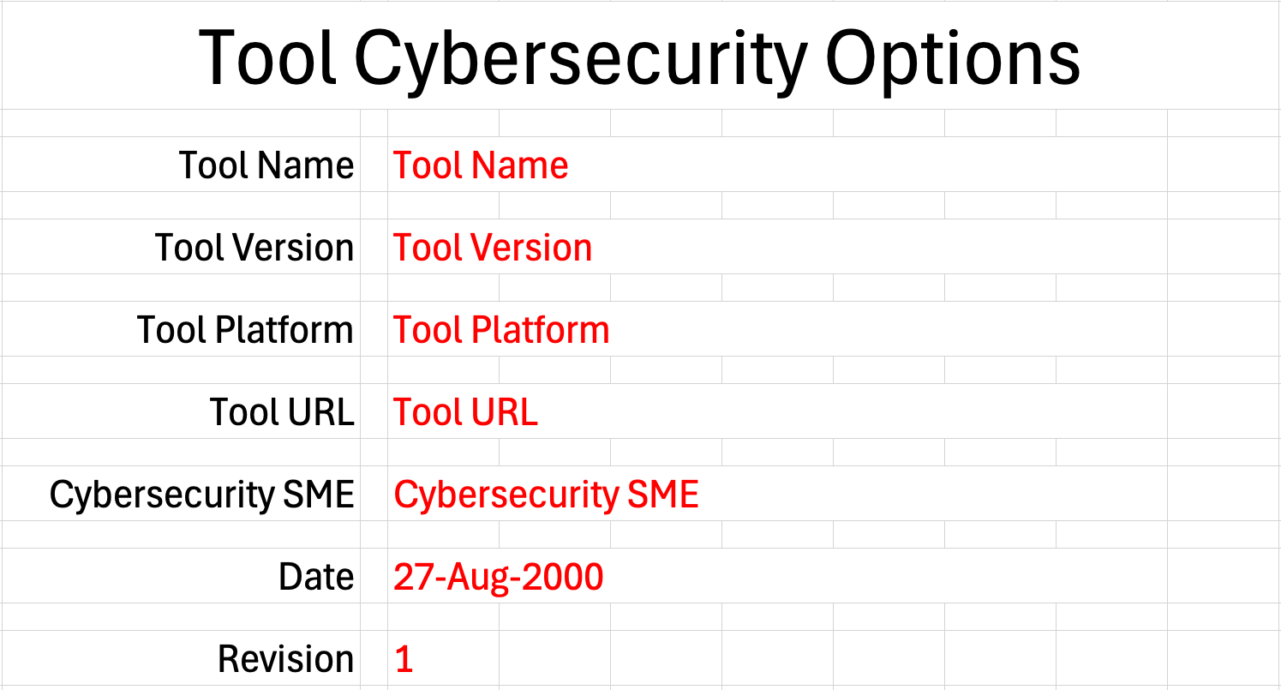
Fields to be completed are shown in red.

Tool Name
This is the name of the tool whose cybersecurity options are being identified.

Tool Version
This is version number of the tool under consideration.

Tool Platform
This is the platform on which the tool is run.

Tool URL
This is location where the tool can be found.

Cybersecurity SME
This is the cybersecurity subject matter expert creating the options list.

Date
This is the date when the options list was created or updated. The date should be updated whenever the list is updated.

Revision
This is the revision number of the document. The revision number is a monotonic and increasing integer, starting at 1. It should be incremented every time the document is updated.

Revision History
The revision history sheet of the workbook is shown below:
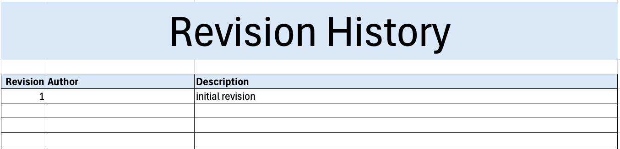

Revision
The revision corresponds to that listed on the cover sheet.

Author
The author corresponds to the threat modeling SME listed on the cover sheet.

Description
This is a brief description of changes made to the threat model since it was last updated.

Reference Documents
Note: References relevant to the categorization of the cybersecurity options should be added to this list.
The references sheet of the workbook is shown below:
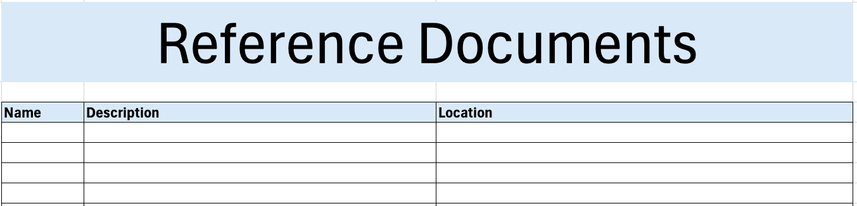

Name
This is the name of the document being referenced.

Description
This is a brief description of the document being referenced.
Note: In cases where the reference material is expressed in the form other than a document (for example, a web page), this should be noted.

Location
This is the location of the document being referenced. It may be a physical location or a URL.

Options
The options sheet of the workbook is shown below:
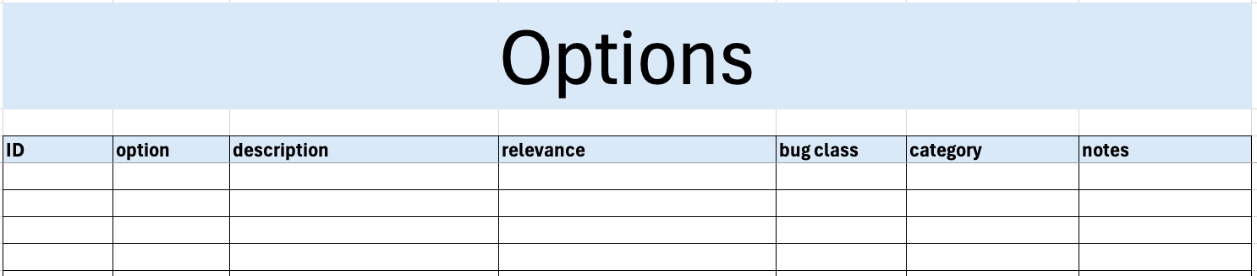

ID
This is the unique ID of the option.
Note: An ID of the form <TOOL>-<zero-leading number> is recommended. Where multiple tools of the same type (such as compilers) use the same options, a generalized tool type should be used for the ID’s prefix.

Option
This is the name of the option.

Description
This is the description of the option.

Relevance
This field describes why the options is relevant from a cybersecurity perspective.

Bug Class
This is the NIST bug class of the option.

Category
This is the option’s security priority category.
Note: Values are populated from the categories sheet.

Notes
This is a general notes field.

Categories
The categories sheet of the workbook is shown below:
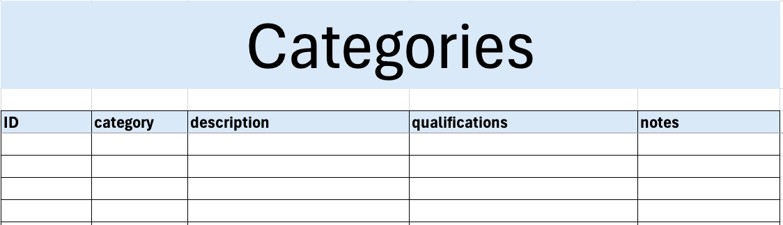

ID
This is the unique ID of the category.
Note: An ID of the form <CATEGORY_CLASSIFIER>-<zero-leading number> is recommended (such as CAT_LMH-2 or CAT_BINARY-1). Where multiple tools of the same categorization use the same values, a generalized categorization methodology name should be used for the ID’s prefix.

Category
This is the name of the category.

Description
This is the description of the category.

Qualifications
This field describes why an options would be placed in this category.

Notes
This is a general notes field.

Legend
The legend sheet of the workbook is shown below:
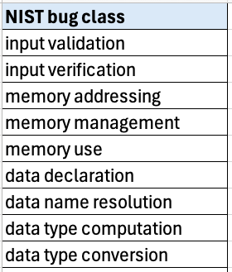
The legend sheet information is used to make the completion of the document easier by providing dropdown lists for common values. It also ensures that spelling errors do not creep into the generated material.
Note: The legend sheet should not be edited. If an unlisted value is required, the template should be separately revised.

Exit Criteria
This procedure is considered complete once the generated output has been entered into the organization’s DMS as a document of record.
Note: The processes and procedures for entering documents into the DMS, or the updating thereof, are outside the scope of this document.

References
- AVCDL (AVCDL primary document)
- Secure Settings Document (AVCDL secondary document)
- AVCDL tool cybersecurity options template (AVCDL template)
- Secure Settings – Identify Options Procedure (AVCDL tertiary document)

